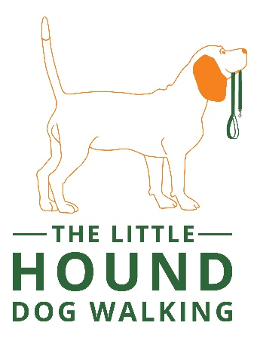
Terms and Conditions (Walking/Sitting)

1. The client agrees to provide full and honest information to The Little Hound about their pets during the booking procedures. Behaviour which may negatively impact on myself (Liane Powell), my own dogs or those on walks. These include but are not limited to excessive barking or anti-social behaviour, aggression towards any humans or animals, straying and phobias.
2. The emergency contact will be asked to take over care for the pet(s) in the event of an emergency, if your pet displayed behaviour which meant they can no longer be cared for. These behaviours can be, but not limited to aggression or anti-social. Refunds will not be given under these circumstances. Please seek permission for an emergency contact to be nominated. The client agrees that if their pet attacks another animal or person, including any representative of The Little Hound and this results in injury to that animal or person, they will be responsible for any expense incurred as a result. This includes payment of veterinary fees incurred as a result of injuries to another animal caused by their dog. The dog will be removed with immediate effect and placed with the emergency contact and no refund will be due.
3. Clients agree to an introductory meeting to allow myself (Liane Powell) to meet the pet(s) and discuss aspects of care. This meeting will take place in your home by arrangement and is provided free of charge.

4. I agree I will be handing over my pet(s) to The Little Hound in good health. Any current illnesses or ailments will be disclosed and any medication for such ailments will be supplied and detailed on the Medication Permission form, overleaf. If a period of more than one month elapses between a booking confirmation and the commencement of service, the client must ensure that The Little Hound are informed of any changes made to the pet’s health, routine or care.
5. All meetings and times are looked upon as appointments and must be followed. If you are unavoidably delayed by more than fifteen minutes, you must contact myself (Liane Powell) before the arranged time to arrange another suitable for any appointment. Please only text to arrange, if you use any other form of messaging this may not be received if I am not in a WiFi enabled area.

6. If the service is cancelled less than 24 hours before commencement then full fees are due. The Little Hound does not charge an extra administration fee for cancelled bookings. Cancellations must be made in writing by email, text or via my Facebook page. A full refund will only be given in the event of the dogs’ death or as a result of serious illness or injury, vets confirmation will be required.

7. The client agrees that their dog(s) will come into contact with other dogs outside whilst being exercised.

9. If a medical emergency arises for your pet(s), The Little Hound will make every effort to contact the client and their emergency contact. Where time is of the essence, the client authorises The Little Hound to seek medical services at the nearest veterinary practice. The client agrees to reimburse for all services rendered by a veterinarian in accordance with the owners wishes as stated and signed in the veterinary release form.
10. Unless otherwise agreed, your pet(s) will be exercised on a harness or collar and a lead. Where a client is happy that their dog is allowed to run free off the lead, they must be willing to sign an off lead disclaimer, under which the client agrees to accept responsibility for accident, injury or loss, caused by or to their dog. Dogs will not be walked in extreme heat, instead they will have garden access for toileting or early walks.
11. In the event of serious accident or illness of myself (Liane Powell) the client accepts that alternative emergency cover may be arranged for their pet(s). This will be done with the involvement of the client’s emergency contact(s).
12. All pets must be fully up to date with their yearly vaccinations or titre tested with certificate of proof (Kennel Cough is not compulsory but is advised), they must also be wormed and treated for fleas/ticks on a regular basis. The Little Hound reserves the right to decline to accept any animal that appears visibly unwell.

13. No animal will be left unattended in a vehicle, unless attending a brief pick up or drop off for other customers and due care will be taken to ensure the pet is safe and comfortable with water if needed.

14. The Little Hound carry out all agreed services in a reliable, caring and trustworthy manner. In consideration of these services and as an express condition thereof, the client waives and relinquishes any and all claims against The Little Hound except those arising from gross negligence or misconduct on the part of The Little Hound.
15. The client authorises the signed contract to be valid approval for future services, therefore allowing The Little Hound to accept future bookings without additional signed contracts or authorisation. By signing below I am promising to read these terms and conditions in their entirety.
I, the undersigned, have read and agreed to the terms and conditions of using the services of The Little Hound. I understand that any outstanding fee will be paid to Liane Powell. I confirm that I will be responsible for any costs which might be incurred, either veterinary or other, as a result of any sickness, accident or damage caused to or by the pet named overleaf, excepting third party liability, and that I will pay such costs on return. By signing these forms I am agreeing to follow through with this booking and pay any fees due.
Client’s name: Client’s signature:

Liane Powell signature: Date:

